JOB SEEKER WORKSHOP

with Discover Ability

March 9th, 2020 from 10:00am - 11:00am
ASC Workshop Room

Funded by the Government of Ontario, Discover Ability is a free online job-matching portal and resource that connects Ontario businesses directly to people with disabilities

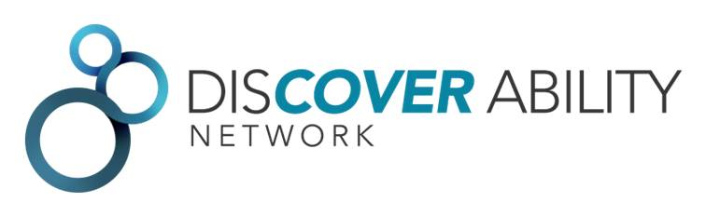

Come join us for an introduction to this platform as well as learning how:
- To productively talk about disability and/or disclose to an employer that an accommodation is required.
- To distill your abilities into one or two sentences that distinctively summarize your skills and abilities to potential employers
- Disability can affect job search and how to maximize your story and stand out from other candidates to get hired

A partnership between Career Development and the Access & Support Centre

Registration required - to register email paula.desaulniers@durhamcollege.ca

