SPOKEN WORD WORKSHOP

with Patrick de Belen

March 12th, 2020 from 1:00pm - 2:30pm
SSB 116

An interactive Spoken Word experience. Participants will explore the art of performance poetry through a combination of creative writing activities, performance games and free-writes – usually ending in a high-energy open mic. It is difficult to describe the magic that happens when a budding poet spits a piece for the first time, but it’s definitely one of those things you have to be there for. The power of your voice is a force unparalleled to any other weapon on this planet. Try it yourself!

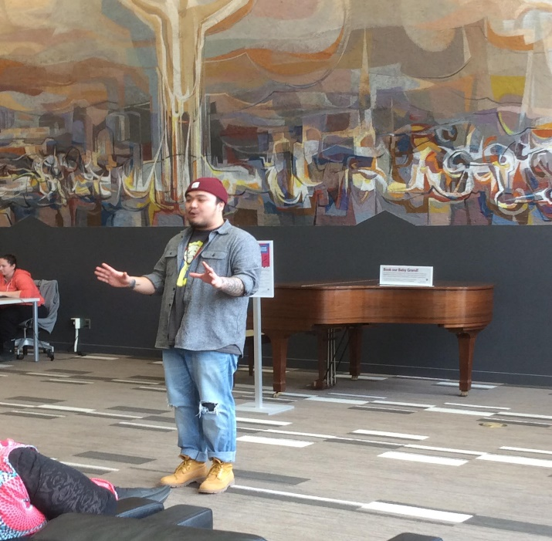

Patrick de Belen is a Toronto-based Filipino spoken word poet, performer, speaker, host and educator whose formidable acclaim as a performance artist and writer is equaled by his commitment to his community, and his status as an enduring source of insight, energy and mentorship for young poets across North America.

Registration required - to register email paula.desaulniers@durhamcollege.ca

