Recommended announcement to post in DC Connect

Just Launched: Course Progress Hub
Hi Everyone,
You may have noticed a new widget at the top right corner of the course homepage called the Course Progress Hub. This is a new tool to help you easily monitor your individual progress in this course, so you can stay on track towards a successful course outcome.
This Hub provides real-time updates on your grade average, will notify you if an assessment has been missed, allows you to see your progress through course content pages, and has a What-If calculator to help you determine minimum required grades on assessments to achieve your desired level of success.
You will see one of three options, which is aligned with your grade range: green (left), yellow (middle), or red (right) below.
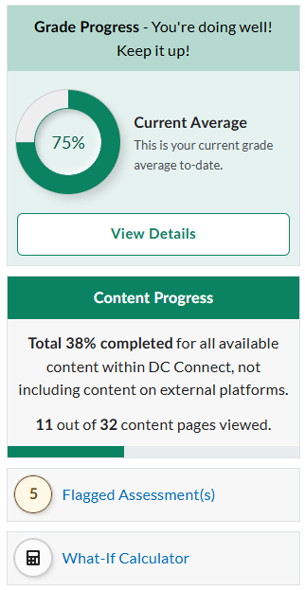
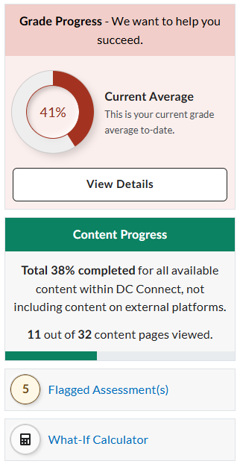
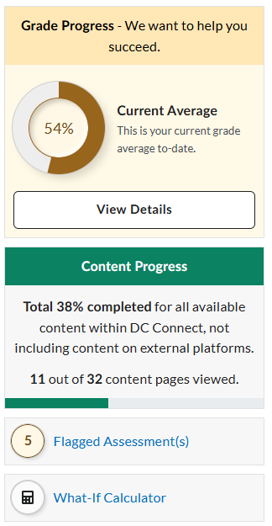

As grades are populated over the semester, these averages will change. The Hub is meant to serve as an additional feature to help you understand your progress and support successful course completion. However, as always, you can reach out to me for support or questions.
The Hub is set to open each time you open the course, but you may close it by selecting the “collapse” button at the top of the widget.

