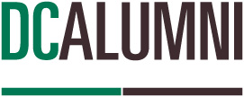

DC Talks: Alumni Series
“Climate Change and Sustainability- How We Can Make a Difference”
November 16, 2022
10:30 AM – noon EST
Global Classroom

Class Plan

- Welcome L Appleby (3 min)
- Class description
- Introduce Don Lovisa

- DC Land Acknowledgement D Lovisa (2 min)

- Topic Summary/ Introduction of panelists D Lovisa (10 min)
- Ellen Campbell
- Heather Brown
- Kathryn Fraser

- Discussion D Lovisa (40 min)

- Questions from students/audience L Appleby (15 min)

- Summary- key points/takeaways L Appleby (3 min)

- Closing D Lovisa (2 min)

