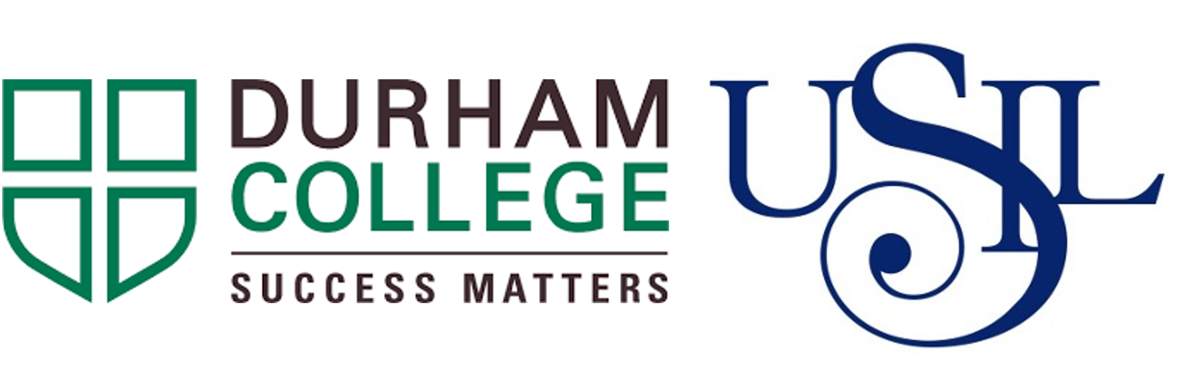
Lima, Peru
USIL Gastronomy Tour
February 21 - March 1, 2025 (approx.)

Application deadline is
Monday, September 30, 2024 by 4 p.m.

Information Session will be held on
TBD week of Sept 9 at TBD pm
in person in B-101

USIL Gastronomy Tour Description
Peru is one of the top culinary destinations in the world! Students will have the opportunity to master traditional Peruvian cuisine techniques, use and apply traditional Peruvian ingredients and learn traditional Peruvian baking and dessert recipes. Furthermore, students will explore the Minka Market, downtown Lima, and have an opportunity to explore Lima’s rich cultural history.

For more information, contact Chef Tanya Heck from the Centre for Food at tanya.heck@durhamcollege.ca or educationabroad@durhamcollege.ca

Timeline
- Application deadline: Monday, September 3, 2024 by 4:00 p.m.
- Initial Deposit: For those accepted for this opportunity, a $500 non-refundable deposit will be due by October 30th, 2024.
- Departure Date: February 21, 2025 (exact departure date to be determined).
- Return Date: March 1, 2025 (exact return date to be determined).

Location
Lima, Peru

Partner Institution
Durham College has a formal partnership with Universidad San Ignacio de Loyola.

Language
The course will be conducted in English.

Accommodations and Meals
Local hotel accommodations are provided. Rooms will be based on double or triple occupancy (mm/ff). Some meals will be provided as part of the culinary program, other meals will be the responsibility of the student.

Student Support
DC students will be supported by both DC and USIL faculty. Two faculty members from the Centre for Food will also accompany the successful candidates to Peru. In addition, DC students will participate in local and cultural events.

Visa and Passports
Canadian students are not required to apply for a tourist visa for Peru. Passports must be valid for six months after the return date. You must provide a copy of your passport by December 15, 2022. Students that do not hold Canadian Passports may be required to secure a Visa at their own expense. Be aware that flights may connect through countries other than Canada and Peru and may affect your ability for obtaining additional visas.

Academics
- You will be required to research and document the classical/traditional cuisine of Peru. You will write an essay or create a presentation on regional ingredients, dishes and other cultural influences of Peru.
- Upon return to Canada, you will demonstrate a recipe your learned while away. Example will be provided.

Things to know:
- Must attend pre-departure training.
- This program includes the preparation of, and tasting of meat, fish and shellfish dishes.
- Must follow the DC Student Code of Conduct throughout the duration of the program.
- Recipients are responsible for all associated pre-departure medical requirements, including vaccinations.

Money Matters
Program Cost will be discussed at the information session. An estimate of costs is as follows, but these are not final and subject to change:

- 5 days of study at USIL, Program Cost $1,500 CDN (approx.) per student
The above costs include classes, accommodations, some meals, tours etc…
- Not included: International flights – approx. - $1,400
- Extras – meals, shopping, etc… $300-600
- A non-refundable deposit of $500 will be required upon acceptance.

Total cost per student is approximately $3200-$3500.
- Up to $1500 may be provided as a bursary

After acceptance into the program your $500 non-refundable deposit will be due by October 30th 2024.

Program Information
(subject to changes due to flight schedules)

Friday Feb 21
Leave Canada – International Flight to Lima, Peru

Saturday Feb 22
Local tour of area

Sunday Feb 23
Walking tour Kennedy Park
Tour of Huaca Pullcana Historic Site and Museum (approx $7.50 cdn)
Local Craft Market

Monday Feb 24
City Tour
Museo Larco
Peruvian Cuisine Workshop

Tuesday Feb 25
Guided tour of Minka Market
Walking tour of Callao Monumental
Pisco Tasting

Wednesday Feb 28
Peruvian Cuisine Workshop
Peruvian Dessert Workshop

Thursday Feb 29
Tour of Barranco District
Restaurant Tour
Visit to Parque de la Aguas

Friday Mar 1
Peruvian Cuisine Workshop
Certificate Ceremony

Sat Mar 2
Return to Canada
Application Information

Eligibility Criteria
- Open to students in Culinary Skills or Culinary Management.
- Good academic standing & record of attendance.
- Students must maintain a GPA of 3.0 (GPA will be confirmed at midterm of fall semester)
- Demonstrates teamwork through commitment to providing peer support & mentoring classmates.
- Once all applications have been received and evaluated a personal interview may be required.

How to apply
You are required to complete an online application found here

https://durhamcollege.ca/forms/flca-culinary-management-peruvian-gastronomy-tour

You are required to answer a series of questions as well as provide an introduction.

- What excites you about this opportunity (maximum 100 words)?
- What do you hope to learn or discover (maximum 100 words)?
- How will this opportunity benefit you?
- What challenges can you anticipate and how will you prepare yourself for this FLCA opportunity?
- Identify and discuss examples of your volunteer work, teamwork, mentorship, and leadership skills?
- How will you work effectively as a team member in a cross-cultural environment?
- How will you share this opportunity with others when you return?
Let us get to know you! Introduce yourself, your relevant skills and experience, and your interests! There is no restriction of how you are going to introduce yourself. The following are some suggestions:

APPLY NOW!!
- Short essay
- Resume
- Photo board
- Animation
- Drawing
- Video
- Other

