pH Determination of Household Compounds using Red Cabbage Indicator

INTRODUCTION

pH is a measurement of the concentration of hydronium ions in solution. A solution with more hydronium ions has a lower the pH than a solution with fewer hydronium ions. The pH scale starts at 0 which is acidic and goes up to 14 which is considered basic with a pH of 7 being neutral.
Each increase of 1 point on the pH scale represents a 10 fold increase in the concentration of acidity or basicity i.e. a solution with a pH of 3 is 10x more acidic than a solution with a pH of 4.

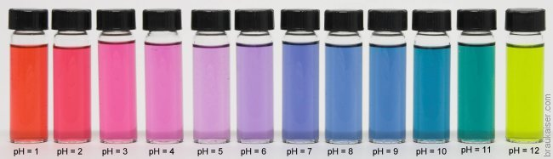
Figure 1. This series of vials represents the various colours of a red cabbage indicator solution under different pH conditions. Note not all possible pH conditions are shown.

Testing the pH of compounds can be done in many different ways in a laboratory but a safe and convenient way to determine the pH of a solution at home involves a colour change indicator prepared using red cabbage. The pH of a solution will affect both the colour and intensity of the colour change indicator.
The colour change is actually a result of something that happens on a chemical level to a compound in cabbage known as cyanidin. This compound is capable of is capable of a chemical change that results in a pink colour under acidic conditions and a blue colour under basic conditions.
The goal of the experiment will be to prepare a coloured cabbage indicator and test the pH of various household compounds.

Teacher Instructions

Please prepare the following prior to the event:

METHOD

- In your box is a red cabbage. Please cut up to 2 to 3 cups and boil in a large pot. Allow it to boil until the cabbage is tender.
- Once cooked, please turn off and allow to cool – approximately 30 minutes. Remove cabbage and once the liquid has cooled please put in the ice cube trays and freeze. There are plastic bags so that once the cubes have set you can put them in there. You will want to have enough ice cubes for 3 to 4 cubes per student.
- Allow remaining liquid to be kept in fridge until your ice cube trays are emptied and can be refilled.

These bags of ice cubes will need to be brought to class the day off. Within the student’s packages they will have plastic glasses. Within your kit is also some baking soda, tums and lime juice that you can share with students.

Each student in their package will have plastic cups, vinegar and stirring spoon.

DAY OF EVENT – For Teacher and Students

- Testing
  - Fill each clear cup with a sample of your household compound to be tested.
    - For solids, try to first dissolve it in water.
    - Also try to use an equal portion of liquid for each sample.
  - Place an indicator containing ice cube in each sample cup and stir.
  - Observe the colour before and after the addition of the indicator.
  - Make inferences as to the relative pH of each sample

QUESTIONS

- What colour did your solution turn upon the addition of vinegar? Baking soda?

- What was the most acidic compound you tested according the results of the experiment? What was the most basic?

- Based on the results of this experiment, do you think a difference in pH of 0.1 would be easily detectable? Why or why not?

