
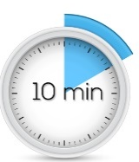
Test Centre Policies

Arrival 5-10 minutes before confirmed appointment
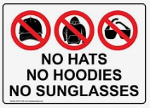

Photo ID Required Hard-copy Government photo ID or the DC app with a photo
All hats and hoods must be removed and remain off for the duration of testing
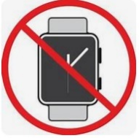
All watches and smart devices must be off the body and in a locker. Phones must be turned off and placed in the locker.

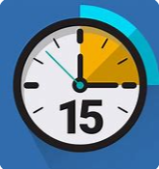
Late arrivals will be permitted entry at the discretion of the TC and/or teacher. Only time remaining in the test booking will be available. The no-show policy is in effect after 15 minutes and fee applied
Water is permitted, and labels removed


Breaks: Remain in your seat for the first 30 minutes: Breaks will be permitted after the first 30 minutes of receiving the test or password. Washroom breaks are escorted
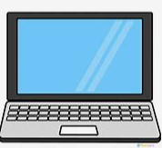
Memory aids must be pre-approved and submitted more than 3 business days in advance by the teacher
Personal laptops are required for all tests hosted on dc connect

Laptops can be borrowed from the library
Academic integrity is taken very seriously. Violations will be reported


Booking deadlines: class tests must be booked more than 7 days in advance: missed tests must be requested more than 3 business days in advance.
Respect your fellow students, staff and proctors

